**Name: Pradnya Badole**

Collection Assignment Framework

1. Write a program to calculate the Simple Interest with minimal code using features of Java 11. Hint: Use the concept of functional interface and Local variable syntax for lambda parameters.

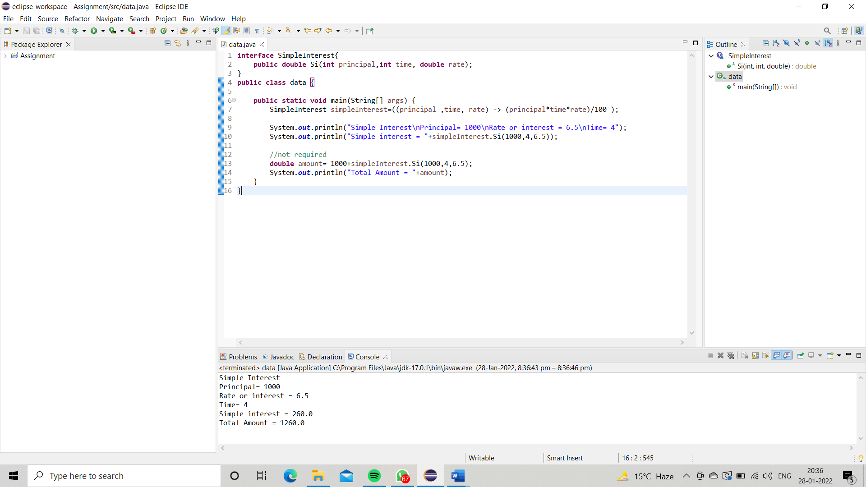

1. Java 11 supports var keyword for variable declarations. List the scenarios where var keyword cannot be used for such variable declarations. Give reason in support of your answer for each scenario.

Ans:

You can use var only for local variables (in methods). It cannot be used for instance variables (at class level). You cannot use var in Lambda expressions.

1. **We can declare any datatype with the** **var keyword**
2. **var can be used in a local variable declaration**
3. **var cannot be used in an instance and global variable declaration.**
4. **var cannot be used as a Generic type**
5. **var cannot be used with the generic type.**
6. **var cannot be used without explicit initialization.**
7. “An apple a day keeps the doctor away”. Create an ArrayList from the given String. Such an ArrayList should include each word from the given sentence. Finally convert such List to an array using Java 11 methods and print the output

